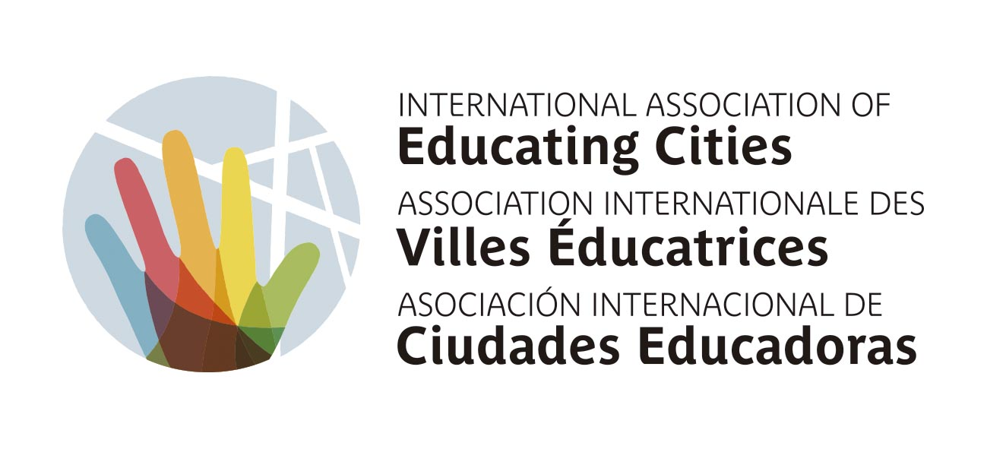
CODE OF ETHICS

CONTENTS
1. Introduction
2. Mission
3. Values
4. Stakeholders
5. Policies
5.1. Sponsors and suppliers
5.2. Relationship with other entities
5.3. Gifts
5.4. Abuse and complaints
6. Reviewing and sharing the Code of Ethics
7. Effective date

1. INTRODUCTION
This Code of Ethics sets out to define the identity of the International Association of Educating Cities (IAEC) and the behaviour expected of everyone linked or related to it. Adoption of this Code defines the ethos and culture of the organisation, while our values and some guidelines are presented to guide the decision-making processes taken on by the people in the organisation.

Purpose of the Code of Ethics:
- To define the values by which the Association wishes to be characterised.
- To create an inclusive, respectful, educating and safe environment for everyone involved.
- To outline certain policies to know how to proceed with specific situations and problems.

2. MISSION
As established in the Charter of Educating Cities, the purpose of this Association is to build a community and a free, responsible and supportive citizenship, capable of living together harmoniously in situations of disharmony, of peacefully resolving their conflicts, and of working together for the common good. These citizens are aware of the challenges facing humanity today and draw on their knowledge to jointly pioneer the search for solutions required by today's historical context.
We understand education as a lifelong process that helps arouse conscience in order to reconcile freedom with responsibility, triggering the sense of interdependence between people and nature as a way of inhabiting the city and the planet. This involves fostering reflection and critical thinking, being to understand complex problems, and encouraging co-responsible engagement in policy design and development, as well as imagining and promoting ways of life that do not involve the destruction of land or inequality among people.

3. VALUES
These are the values included in the Charter of Educating Cities. They govern the IAEC, and we are committed to following them.

- Equality and integrity. Everyone has the same dignity, regardless of circumstances, and therefore deserves the same consideration and respect. We are committed to promoting conditions of full equality so that everyone feels respected and is respectful, capable of dialogue and active listening. Consequently, we oppose any type of violation of rights or discrimination based on colour, ethnic origin, gender, age, culture, religion, ideology, functional diversity, sexual orientation, position or any other circumstance susceptible to discrimination, which violates the most elementary principles of human dignity.

- Solidarity and responsibility. Fully aware that people are interdependent with each other and with the planet, we want this awareness to translate into solidarity. What's more, we take responsibility for our privileges or facilities in order to care for our environment and for people who find themselves in more difficult conditions. In particular, we want to pay special attention to any vulnerable, precarious, less visible or less socially legitimated group. We want this sense of solidarity and responsibility to influence us both on a daily and local level and on a global level, promoting solidarity among the IAEC cities, taking an interest in global challenges, and committing ourselves to giving a response, as far as possible.
We encourage intergenerational dialogue with common and shared projects among groups of people of different ages.

- Democratic trust. Our Association, aside from encouraging the individual growth of people, also sets out to nurture collective skills and contribute to the common good. In this way, we promote democratic trust, which is the practice of peaceful and harmonious living through education in ethical and civic values, respect for the plurality of the various possible forms of democratic government, and the encouragement of quality representative and participatory mechanisms. As a result, we are committed to fostering dialogue, active listening, community awareness, and citizen engagement. In this way, we build a sense of democratic and global citizenship based on the continuous experience of joint responsibility in a collective initiative. We also promote the engagement of cities within the Association and on the level of representation and coordination, and we nurture a decentralised organisation in territorial networks that means we can address and respond to the various challenges and needs of different territories.

Transparency is the foundation of trust. The IAEC requires people in leadership positions, employees and members to be honest, transparent and fair in the management of resources, subsidies or aid and in commercial and institutional relations; and to respect the financial statement and the exercise of any of their functions.

A commitment to confidentiality will be another critical component of trust. The IAEC recognises that information is one of its main assets, essential for the management of activities. Therefore, one of its objectives is to preserve the integrity, availability and confidentiality of information, thereby minimising the risks derived from its disclosure and misuse.

- Exemplarity and institutional loyalty. Any person linked to the IAEC must bear in mind that they are committed to the association and that the actions they carry out within it also represent the IAEC's values. In particular, members of the Executive Committee, staff of the Secretariat, and members of the various branches and networks must lead the association by example, defending collective interests and — by extension — adhering to the commitments and guidelines of conduct described in this Code. Their behaviour must be a model to follow for all other members and, in this way, preserve the trust of the General Assembly and partner entities.

Exemplarity and institutional loyalty also apply to the use of social media, both institutional and personal. It is important to be aware that the content shared, followed and posted by IAEC members, especially those with positions of greater responsibility, will be closely linked to the Association's image.

Meanwhile, the responsibility and transparency that characterise the IAEC mean that any conflict of interest in decision-making processes should be avoided. By conflict of interest, we understand the prioritisation of personal or professional interests over those of the organisation. If someone has a conflict of interest, they need to lay it on the table to find a common way to manage it.

Finally, to ensure that personal identities and interests do not interfere with the functioning of the IAEC, political and religious independence will be upheld. In other words, the Association recognises the right of its members and employees to exercise their freedom of expression, political thought and participation in public life, provided that it does not interfere in the performance of their activity in the IAEC, and provided that said participation does not lead an external observer to associate the IAEC with one or another political option.

- Sustainability. We actively promote the participation and co-responsibility of everyone at the IAEC in the adoption of fair, resilient and sustainable lifestyles and consumption, under the principles of sufficiency, sharing and justice. Therefore, it always guarantees that sustainability criteria govern members' activities, and it calls for compliance with the environmental procedures and requirements applicable in each case.

4. STAKEHOLDERS

This Code refers to the actions of people who are continuously linked to the Association, as well as those who occasionally participate during their membership. All of them have the duty to know, comply with and enforce this Code, and assume the duty to report any breach or practice which they observe or learn about that is contrary to its content. They can also submit improvements and suggestions regarding the Code.

On the level of internal stakeholders, this Code of Ethics is particularly important for employees and leaders of the IAEC. However, it should also be known and respected by external stakeholders, such as sponsors, suppliers or volunteers.

To ensure the compliance, awareness, relevance and review of the Code of Ethics, an Ethics Committee will be created. This Committee will be the body in charge of receiving complaints and reports regarding breaches of the code, as well as suggestions, proposals for improvement, or queries in the case of complex situations and problems in which there are conflicts of values and doubts about the best option to choose.

If the situations under review are criminal or could entail criminal behaviour, the persons involved may report them directly to the IAEC Executive Committee.

Up to this point, the Code of Ethics has consisted of explaining the values that guide us. From now on, and to make its application more efficient, we are going to discuss specific and more formal policies to encourage certain behaviours and eradicate conduct that we consider is contrary to the values mentioned above.

5. POLICIES

5.1. Sponsors and suppliers

As far as possible, the IAEC will seek to forge relationships with suppliers and sponsors who work with values close to those that govern the Association's activity. In this regard, the following criteria will be taken into account:

1) Objectivity. The Association must have clear and publicly known criteria for the selection of suppliers and sponsors, which will be reviewed regularly to meet the most satisfactory conditions for the Association, and which are respectful of its mission and values.

2) Quality. Suppliers and sponsors must guarantee the Association a scrupulous service with the best possible conditions in order to contribute to the success of its mission.

3) Independence. The governing bodies of the Association and the persons authorised to secure contracts and sponsorships must maintain integrity and objectivity in the supply processes entrusted to them.

The practical guidelines related to these criteria are:

- The following characteristics will be considered for the selection of suppliers and the search for sponsors: quality, proximity, price, additional services, and the social value they provide. As for suppliers, efforts will be made to choose the services and products of social enterprises (social integration companies, cooperatives, etc.), within those available in the market. The Association will prioritise the internal purchase and use of environmentally friendly, sustainable, fair trade and, in general, socially and culturally valuable services and products. The same guidelines will apply to the pursuit for sponsors.

- With regard to suppliers, if any members of the Executive Committee or their direct relatives, or anyone who is their spouse, partner, or second degree relative by blood or by marriage, are related to any person contracted by the Association to provide services or products, there will be the utmost transparency, responsibility, and confidentiality.

Here is a short checklist for assessing entities with which the IAEC wishes to partner:

- Fundraising:
Is the type of the funding entity appropriate for the funds required?
Does the partnership in question pose any risk to the IAEC's reputation?
- Donations:
Do we know the origin of the donations received?
- Allocation of funds:
Is the allocation of funds public?

5.2. Relationship with other entities

Partnership agreements will be established with social agents (universities, trade unions, business organisations, the media, etc.), provided that they respond to the IAEC's mission and values and help improve its work.

The reasons for this include criteria such as: consistency with values. For each partnership with another entity, the reason and the duration or expected continuity will be specified. Relationships will not continue in the event of discrepancies in values and procedures that cannot be resolved. Meetings and seminars will be promoted with organisations that pursue the same goals.

5.3. Gifts

Any person from the Secretariat, the Executive Committee, delegations or network-coordinating cities may only offer, request or accept, directly or indirectly, gifts, favours or compensation for courtesy reasons, which we understand as gestures of gratitude whose value is symbolic and of negligible value.
In cases where, due to their origin or characteristics, the acceptance of the gifts may result in doubts, on an individual basis, it will be up to the Presidency and the Treasury of the IAEC to decide on their use or possible return.

Cash gifts are strictly prohibited.

5.4. Abuse and complaints

A distinction must be made between breaches of the Code of Ethics or morally reprehensible conduct and abuse which is deemed an offence or a crime. The IAEC is committed to responding to complaints from anyone who may have felt discriminated, intimidated or abused.
Possible offences or crimes will be addressed by the Ethics Committee and discussed within the Association. In the event of abuse or discrimination due to social class, origin, ethnicity, gender, age, sexual orientation, functional diversity, position or any other reason, complaint processes will be initiated.

The IAEC Executive Committee is the body empowered to investigate the procedure and agree on the corresponding sanction. In accordance with Article 24 of the Bylaws, agreements to initiate the sanctioning process will be taken by a simple majority. Based on the severity, violators will be given a warning, temporarily excluded from IAEC activity, or permanently excluded.

There are two channels for reporting breaches of the Code of Ethics. One is the email address iaec_ethic_mailbox@bcn.cat. Meanwhile, in cases that affect the staff of the Secretariat, breaches must be reported via the Ethics and Good Governance Mailbox of Barcelona City Council. The report must include all the data and details known. If requested by the whistleblower, anonymity will be respected. Both channels are solely and exclusively for reporting possible behaviours which may involve conduct that violates this Code of Ethics. They are not channels for sending complaints or disagreements, for which the IAEC has implemented other channels.

Complaints filed to the IAEC Executive Committee will not affect the individual right to report the alleged infringement to the competent authorities, provided that it is an administrative, civil or criminal offence under the applicable legislation. For its part, the IAEC will decide whether to uphold the complaint before the judicial institutions.

6. REVIEWING AND SHARING THE CODE OF ETHICS

The IAEC undertakes to communicate, share and review this Code so that it is known and respected by all members of the network. It will also be added to the Transparency section of the Association's website.
This Code of Ethics is a living element: the Association's activity and realm are constantly evolving, so the Code will be reviewed and updated when necessary. Any changes or updates to this Code of Ethics will be communicated to members of the organisation.

7. EFFECTIVE DATE

This Code of Ethics takes effect the day after it is approved, and all members will be informed of it. Its validity will be indefinite, unless the Executive Committee or the Assembly decides otherwise.

The value of the gift may not exceed EUR 50 in Europe. A similar criterion should be applied in other countries, taking into account the value of the currency and the economic context of the place where the event takes place.

